FRANK MARINO
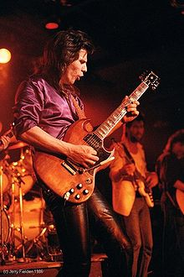
Frank Marino (Francesco Antonio Marino), born November 20, 1954, in Montreal, is the guitarist and leader of Canadian hard rock band Mahogany Rush. Often compared to Jimi Hendrix, he is acknowledged as one of the best and most underrated[2] guitarists of the 1970s.

After playing drums since he was five,[3] around age 13-14 Marino started playing guitar.[4] An often-repeated myth is he was visited by an apparition of Jimi Hendrix after a bad LSD trip,[5][6] a myth Marino has always disavowed, and still does so now on his personal website.[7] His playing, however, is explicitly inspired by Hendrix (on the Gibson he is described as "carrying Jimi's psychedelic torch"[8]), and Marino is notable for strong cover versions of Hendrix classics such as "Purple Haze".[1][8] He has been criticized by some as a Hendrix clone.[9][10] Marino himself claims that he didn't consciously set out to imitate Hendrix's style at all: "The whole style just came naturally. I didn't choose it; it chose me."[11]
Mahogany Rush was moderately popular in the 1970s. Their records charted in Billboard, and they toured extensively, playing such venues as California Jam II (1978). Toward the end of the 1970s, the band began to be billed as "Frank Marino and Mahogany Rush."[12] Not much later, Mahogany Rush split up and in the early 1980s Marino released two solo albums on CBS. The band reformed and continued to perform throughout the 1980s and 1990s. In 1993, Marino retired from the music industry.
Marino returned in 2001, inspired in part by a fansite, www.mahoganyrush.com: "I always knew we had fans, I just didn't know I'd find half a million of them on the Web," he said in an interview with Guitar Player in 2005.[3] He released Eye of the Storm, and went on tour again, playing more improvisational shows.[3] Frank is still active, recording and touring under his own name. He has also been involved in blues recordings with other artists as well, playing on tribute albums to Albert King and Stevie Ray Vaughan.

